OBJECTIVES:

HTTP Request and Response:

1. HTTP Request
An HTTP Request is a message sent by a client (browser or application) to a server asking for a resource or service.
Example:
GET /index.html HTTP/1.1
Host: www.example.com
User-Agent: Chrome
Content-Type: application/json
2. HTTP Response
An HTTP Response is a message sent by the server back to the client containing the requested data and status information.
Example:
HTTP/1.1 200 OK
Content-Type: text/html

<html>
<body>Hello World</body>
</html>
3. HTTP Request Format
An HTTP Request consists of:
- Request Line → Method, URL, HTTP Version
- Headers → Additional information
- Body → Data sent to the server (optional)
4. HTTP Response Format
An HTTP Response consists of:
- Status Line → HTTP Version, Status Code, Status Message
- Headers → Additional information
- Body → Response content
5. Request URL
The Request URL identifies the location of the resource on the server.
Example:
https://www.example.com/products
6. Request Method
The Request Method specifies the action to perform.
Method | Purpose
GET | Retrieve data
POST | Create new data
PUT | Update data
DELETE | Delete data
7. Content-Type
The Content-Type header specifies the format of the data being sent.
Examples:
application/json
text/html
application/xml
8. User-Agent
The User-Agent header identifies the client application making the request.
Example:
User-Agent: Mozilla/5.0 Chrome/138.0

2.Need and Benefits of RESTful Web Services:

What is REST?
REST (Representational State Transfer) is an architectural style used for developing web services. It is lightweight, scalable, and easy to maintain. RESTful services use HTTP as the underlying protocol for communication between clients and servers.
Components of REST
- Resources – Data or objects identified by URLs.
- Verbs (HTTP Methods) – GET, POST, PUT, DELETE.
- Headers – Metadata about requests and responses.
- Body – Data sent between client and server.
- Response Status Codes – Indicate request results (200 OK, 404 Not Found, etc.).
- Client-Server Architecture – Separates user interface from data storage and processing.
Need for RESTful Web Services
- Enables communication between different applications.
- Supports web, mobile, and cloud-based systems.
- Provides a standard way to access and manipulate resources.
- Simplifies integration between heterogeneous systems.
Benefits of RESTful Web Services
- Lightweight – Uses simple HTTP protocol.
- Scalable – Handles large numbers of clients efficiently.
- Maintainable – Easy to modify and extend.
- Platform Independent – Works across different programming languages and platforms.
- Flexible Data Formats – Supports JSON, XML, etc.
- Improved Performance – Stateless communication reduces server load.
Conclusion
RESTful Web Services provide a simple, efficient, and scalable approach for building modern web applications using HTTP-based communication.
3.Demonstration of RESTful Web Service using GET Method:
1. @RestController
@RestController is used to create RESTful web services in Spring Boot. It combines @Controller and @ResponseBody.
@RestController
public class HelloController {
}

2. @GetMapping
@GetMapping maps HTTP GET requests to a specific method.
@RestController
public class HelloController {

@GetMapping("/hello")
public String hello() {
return "Hello World";
}
}
Output:
Hello World

3. Invoking GET Request from Browser
Enter the URL in the browser:
http://localhost:8080/hello
Response:
Hello World
4. Invoking GET Request from Postman
- Open Postman
- Select GET
- Enter URL:
- http://localhost:8080/hello
- Click Send
Response:
Hello World

5. Bean Transformation to JSON
Spring Boot automatically converts Java objects into JSON.
class Country {
private int id;
private String name;

public Country(int id, String name) {
this.id = id;
this.name = name;
}

public int getId() { return id; }
public String getName() { return name; }
}
@RestController
public class CountryController {

@GetMapping("/country")
public Country getCountry() {
return new Country(1, "India");
}
}
JSON Output:
{
"id": 1,
"name": "India"
}

6. GET Method with Parameter (@PathVariable)
@RestController
public class CountryController {

@GetMapping("/country/{id}")
public String getCountry(@PathVariable int id) {
return "Country Id: " + id;
}
}
URL:
http://localhost:8080/country/101
Output:
Country Id: 101

7. Returning an Array
@RestController
public class CountryController {

@GetMapping("/countries")
public String[] getCountries() {
return new String[]{"India", "USA", "Japan"};
}
}
JSON Output:
[
"India",
"USA",
"Japan"
]

8. Role of Dispatcher Servlet
- Front Controller in Spring MVC.
- Receives all incoming HTTP requests.
- Maps requests to appropriate controller methods.
- Processes the response and sends it back to the client.
Summary
- @RestController → Creates REST APIs.
- @GetMapping → Handles GET requests.
- Browser/Postman → Used to invoke GET APIs.
- Bean to JSON → Spring converts Java objects to JSON automatically.
- @PathVariable → Reads values from URL.
- Array Return → Returned as JSON array.
- Dispatcher Servlet → Routes requests to controllers.

4.End-to-End Testing of RESTful Web Service using MockMvc:

1. What is MockMvc?
MockMvc is a Spring testing framework used to test REST APIs without starting the actual server. It simulates HTTP requests and verifies responses.
2. @AutoConfigureMockMvc
@AutoConfigureMockMvc automatically configures the MockMvc object for testing.
@SpringBootTest
@AutoConfigureMockMvc
class CountryControllerTest {
}

3. MockMvc
Inject MockMvc using @Autowired.
@Autowired
private MockMvc mockMvc;

4. @Test
@Test is used to define a test method.
@Test
public void testGetCountry() {
}

5. Testing GET Request using get() and perform()
@SpringBootTest
@AutoConfigureMockMvc
public class CountryControllerTest {

@Autowired
private MockMvc mockMvc;

@Test
public void testGetCountry() throws Exception {

mockMvc.perform(get("/country"))
.andExpect(status().isOk())
.andExpect(jsonPath("$.id").value(1))
.andExpect(jsonPath("$.name").value("India"));
}
}

6. status().isOk()
Checks whether the response status code is 200 OK.
.andExpect(status().isOk());

7. jsonPath().exists()
Checks whether a JSON field exists.
.andExpect(jsonPath("$.id").exists());

8. jsonPath().value()
Checks the value of a JSON field.
.andExpect(jsonPath("$.name").value("India"));

9. Testing Bad Request
@Test
public void testBadRequest() throws Exception {

mockMvc.perform(get("/country/abc"))
.andExpect(status().isBadRequest());
}

10. status().reason()
Verifies the error message (reason phrase).
.andExpect(status().reason("Invalid Country Id"));

Complete Example
@SpringBootTest
@AutoConfigureMockMvc
public class CountryControllerTest {

@Autowired
private MockMvc mockMvc;

@Test
public void testGetCountry() throws Exception {

mockMvc.perform(get("/country"))
.andExpect(status().isOk())
.andExpect(jsonPath("$.id").exists())
.andExpect(jsonPath("$.id").value(1))
.andExpect(jsonPath("$.name").value("India"));
}
}

Test Execution in Eclipse
- Right-click the test class.
- Select Run As → JUnit Test.
- View results in the JUnit View.

Test Execution using Maven
Run all tests:
mvn test
Run a specific test:
mvn -Dtest=CountryControllerTest test

Summary
- @AutoConfigureMockMvc → Configures MockMvc.
- MockMvc → Simulates HTTP requests.
- @Test → Defines test methods.
- get() → Sends GET request.
- perform() → Executes request.
- andExpect() → Verifies response.
- status().isOk() → Checks HTTP 200.
- jsonPath().exists() → Checks JSON field existence.
- jsonPath().value() → Checks field value.
- status().isBadRequest() → Checks HTTP 400.
- status().reason() → Verifies error reason.
- mvn test → Runs tests from command line.

HANDS ON:

- HTTP Request and Response:
HTTP (HyperText Transfer Protocol) is the protocol used for communication between a web browser (client) and a web server.
HTTP Request
When a user enters a URL in a browser, the browser sends an HTTP request to the web server.
Sample HTTP Request
GET /hello.txt HTTP/1.1
User-Agent: curl/7.16.3 libcurl/7.16.3 OpenSSL/0.9.7l zlib/1.2.3
Host: www.example.com
Accept-Language: en, mi
Explanation
Line | Description
GET /hello.txt HTTP/1.1 | Request line containing the HTTP Method (GET), Resource (/hello.txt), and HTTP Version (HTTP/1.1).
User-Agent | Identifies the client (browser or application) making the request.
Host | Specifies the server that should handle the request (www.example.com).
Accept-Language | Indicates the preferred language(s) for the response.
Request Line Breakdown
GET /hello.txt HTTP/1.1
│ │ │
│ │ └── HTTP Version
│ └────────────── Resource Requested
└───────────────────── HTTP Method
HTTP Methods
- GET – Retrieve data from the server.
- POST – Send data to the server.
- PUT – Update existing data.
- DELETE – Remove data from the server.
URL Breakdown
Example URL:
https://www.example.com/hello.txt
- Host: www.example.com
- Resource: /hello.txt

HTTP Response
After processing the request, the server sends an HTTP response back to the browser.
Sample HTTP Response
HTTP/1.1 200 OK
Date: Mon, 27 Jul 2009 12:28:53 GMT
Server: Apache
Last-Modified: Wed, 22 Jul 2009 19:15:56 GMT
ETag: "34aa387-d-1568eb00"
Accept-Ranges: bytes
Content-Length: 51
Vary: Accept-Encoding
Content-Type: text/plain

Hello World! My payload includes a trailing CRLF.
Explanation
Line | Description
HTTP/1.1 200 OK | Status line containing HTTP Version, Status Code, and Status Message.
Date | Date and time when the response was generated.
Server | Information about the web server (Apache).
Last-Modified | Date when the resource was last changed.
ETag | Unique identifier used for cache validation.
Accept-Ranges | Indicates support for partial downloads.
Content-Length | Size of the response body in bytes.
Vary | Specifies headers that affect caching.
Content-Type | Specifies the type of content returned.
Response Body | Contains the actual content requested.
Status Line Breakdown
HTTP/1.1 200 OK
│ │ │
│ │ └── Status Message
│ └────── Status Code
└─────────────── HTTP Version

Common HTTP Status Codes
Status Code | Meaning
200 OK | Request completed successfully.
201 Created | Resource created successfully.
301 Moved Permanently | Resource has moved permanently.
302 Found | Temporary redirect.
400 Bad Request | Invalid request from the client.
401 Unauthorized | Authentication required.
403 Forbidden | Access denied.
404 Not Found | Requested resource not found.
500 Internal Server Error | Server encountered an error.
503 Service Unavailable | Server is temporarily unavailable.

Common Content Types
Content-Type | Description
text/plain | Plain text
text/html | HTML webpage
application/json | JSON data
application/xml | XML document
image/png | PNG image
image/jpeg | JPEG image
text/css | CSS stylesheet
application/javascript | JavaScript file
The browser uses the Content-Type header to determine how to display or process the returned data.

Response Body Examples
Content-Type | Response Body
text/plain | Plain text
text/html | HTML code
application/json | JSON object
image/png | Binary image data
application/pdf | PDF document bytes

Viewing HTTP Requests and Responses in Chrome
- Open Google Chrome.
- Press F12 (or Ctrl + Shift + I) to open Developer Tools.
- Select the Network tab.
- Visit any website (for example, Google).
- Click on one of the network requests.
- Observe the details shown on the right side.
You will typically see:
- General
  - Request URL
  - Request Method
  - Status Code
  - Remote Address
- Request Headers
  - Host
  - User-Agent
  - Accept
  - Accept-Language
  - Cookies
- Response Headers
  - Content-Type
  - Content-Length
  - Date
  - Server
  - Cache-Control
- Response
  - The actual data returned by the server (HTML, JSON, image, etc.).

- Hello World RESTful Web Service:
Solution:
HelloController.java
package com.cognizant.springlearn.controller;

import org.slf4j.Logger;
import org.slf4j.LoggerFactory;
import org.springframework.web.bind.annotation.GetMapping;
import org.springframework.web.bind.annotation.RestController;

@RestController
public class HelloController {

private static final Logger LOGGER = LoggerFactory.getLogger(HelloController.class);

@GetMapping("/hello")
public String sayHello() {
LOGGER.info("START");

String message = "Hello World!!";

LOGGER.info("END");
return message;
}
}

SpringLearnApplication.java
package com.cognizant.springlearn;

import org.springframework.boot.SpringApplication;
import org.springframework.boot.autoconfigure.SpringBootApplication;

@SpringBootApplication
public class SpringLearnApplication {

public static void main(String[] args) {
SpringApplication.run(SpringLearnApplication.class, args);
}
}
application.properties
server.port=8083

Output:
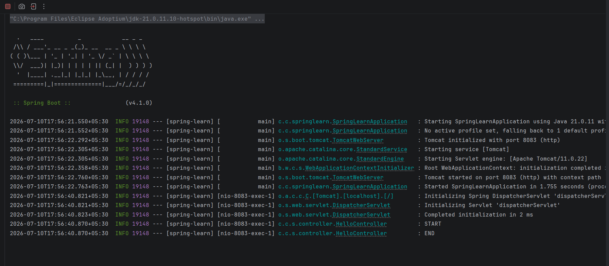

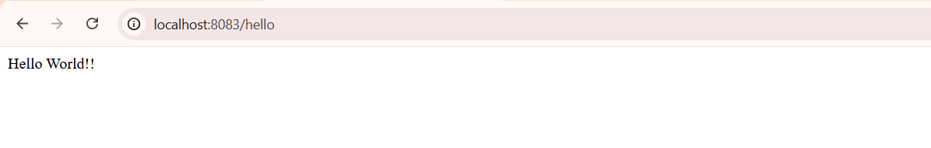
- REST - Country Web Service
Solution:
Country.java
package com.cognizant.springlearn.model;

public class Country {

private String code;
private String name;

public Country() {
}

public Country(String code, String name) {
this.code = code;
this.name = name;
}

public String getCode() {
return code;
}

public void setCode(String code) {
this.code = code;
}

public String getName() {
return name;
}

public void setName(String name) {
this.name = name;
}
}

country.xml
<?xml version="1.0" encoding="UTF-8"?>

<beans xmlns="http://www.springframework.org/schema/beans"
xmlns:xsi="http://www.w3.org/2001/XMLSchema-instance"
xsi:schemaLocation="
http://www.springframework.org/schema/beans
https://www.springframework.org/schema/beans/spring-beans.xsd">

<bean id="country" class="com.cognizant.springlearn.model.Country">
<property name="code" value="IN"/>
<property name="name" value="India"/>
</bean>

</beans>

CountryController.java
package com.cognizant.springlearn.controller;

import com.cognizant.springlearn.model.Country;
import org.slf4j.Logger;
import org.slf4j.LoggerFactory;
import org.springframework.context.support.ClassPathXmlApplicationContext;
import org.springframework.web.bind.annotation.RequestMapping;
import org.springframework.web.bind.annotation.RestController;

@RestController
public class CountryController {

private static final Logger LOGGER =
LoggerFactory.getLogger(CountryController.class);

@RequestMapping("/country")
public Country getCountryIndia() {

LOGGER.info("START");

ClassPathXmlApplicationContext context =
new ClassPathXmlApplicationContext("country.xml");

Country country = (Country) context.getBean("country");

LOGGER.info("Country : {}", country.getName());
LOGGER.info("END");

return country;
}
}

application.properties
server.port=8083

Output:
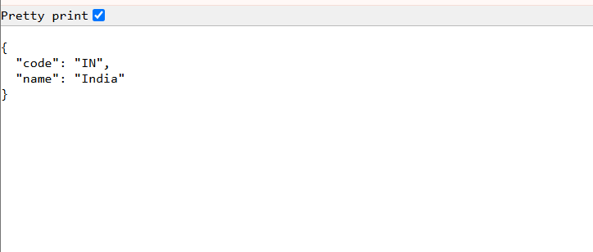

- REST - Get all countries :

Solution:
country.xml
<?xml version="1.0" encoding="UTF-8"?>

<beans xmlns="http://www.springframework.org/schema/beans"
xmlns:xsi="http://www.w3.org/2001/XMLSchema-instance"
xsi:schemaLocation="
http://www.springframework.org/schema/beans
https://www.springframework.org/schema/beans/spring-beans.xsd">

<bean id="countryList" class="java.util.ArrayList">
<constructor-arg>
<list>
<bean class="com.cognizant.springlearn.model.Country">
<property name="code" value="IN"/>
<property name="name" value="India"/>
</bean>

<bean class="com.cognizant.springlearn.model.Country">
<property name="code" value="US"/>
<property name="name" value="United States"/>
</bean>

<bean class="com.cognizant.springlearn.model.Country">
<property name="code" value="JP"/>
<property name="name" value="Japan"/>
</bean>

<bean class="com.cognizant.springlearn.model.Country">
<property name="code" value="DE"/>
<property name="name" value="Germany"/>
</bean>
</list>
</constructor-arg>
</bean>

</beans>

CountryController.java
package com.cognizant.springlearn.controller;

import java.util.List;

import org.slf4j.Logger;
import org.slf4j.LoggerFactory;
import org.springframework.context.support.ClassPathXmlApplicationContext;
import org.springframework.web.bind.annotation.GetMapping;
import org.springframework.web.bind.annotation.RestController;

import com.cognizant.springlearn.model.Country;

@RestController
public class CountryController {

private static final Logger LOGGER =
LoggerFactory.getLogger(CountryController.class);

@GetMapping("/countries")
public List<Country> getAllCountries() {

LOGGER.info("START");

ClassPathXmlApplicationContext context =
new ClassPathXmlApplicationContext("country.xml");

@SuppressWarnings("unchecked")
List<Country> countryList =
(List<Country>) context.getBean("countryList");
LOGGER.info("END");

return countryList;
}
}

Country.java
package com.cognizant.springlearn.model;

public class Country {
private String code;
private String name;

public Country() {
}

public Country(String code, String name) {
this.code = code;
this.name = name;
}
public String getCode() {
return code;
}
public void setCode(String code) {
this.code = code;
}
public String getName() {
return name;
}
public void setName(String name) {
this.name = name;
}
}

Output:
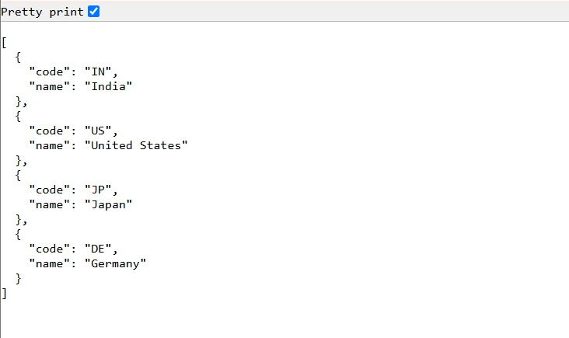
- REST - Get country based on country code
Solution:
CountryController.java
package com.cognizant.springlearn.controller;

import org.slf4j.Logger;
import org.slf4j.LoggerFactory;
import org.springframework.beans.factory.annotation.Autowired;
import org.springframework.web.bind.annotation.GetMapping;
import org.springframework.web.bind.annotation.PathVariable;
import org.springframework.web.bind.annotation.RestController;

import com.cognizant.springlearn.model.Country;
import com.cognizant.springlearn.service.CountryService;

@RestController
public class CountryController {

private static final Logger LOGGER =
LoggerFactory.getLogger(CountryController.class);

@Autowired
private CountryService countryService;

@GetMapping("/countries/{code}")
public Country getCountry(@PathVariable String code) {

LOGGER.info("START");

Country country = countryService.getCountry(code);

LOGGER.info("END");

return country;
}
}

CountryService.java
package com.cognizant.springlearn.service;

import java.util.List;

import org.springframework.context.support.ClassPathXmlApplicationContext;
import org.springframework.stereotype.Service;

import com.cognizant.springlearn.model.Country;

@Service
public class CountryService {

@SuppressWarnings("unchecked")
public Country getCountry(String code) {

ClassPathXmlApplicationContext context =
new ClassPathXmlApplicationContext("country.xml");

List<Country> countryList =
(List<Country>) context.getBean("countryList");

return countryList.stream()
.filter(country -> country.getCode().equalsIgnoreCase(code))
.findFirst()
.orElse(null);
}
}

Country.java
package com.cognizant.springlearn.model;

public class Country {

private String code;
private String name;

public Country() {
}

public Country(String code, String name) {
this.code = code;
this.name = name;
}

public String getCode() {
return code;
}

public void setCode(String code) {
this.code = code;
}

public String getName() {
return name;
}

public void setName(String name) {
this.name = name;
}
}

country.xml
<?xml version="1.0" encoding="UTF-8"?>

<beans xmlns="http://www.springframework.org/schema/beans"
xmlns:xsi="http://www.w3.org/2001/XMLSchema-instance"
xsi:schemaLocation="
http://www.springframework.org/schema/beans
https://www.springframework.org/schema/beans/spring-beans.xsd">

<bean id="countryList" class="java.util.ArrayList">
<constructor-arg>
<list>
<bean class="com.cognizant.springlearn.model.Country">
<property name="code" value="IN"/>
<property name="name" value="India"/>
</bean>

<bean class="com.cognizant.springlearn.model.Country">
<property name="code" value="US"/>
<property name="name" value="United States"/>
</bean>

<bean class="com.cognizant.springlearn.model.Country">
<property name="code" value="JP"/>
<property name="name" value="Japan"/>
</bean>

<bean class="com.cognizant.springlearn.model.Country">
<property name="code" value="DE"/>
<property name="name" value="Germany"/>
</bean>
</list>
</constructor-arg>
</bean>

</beans>

Output:
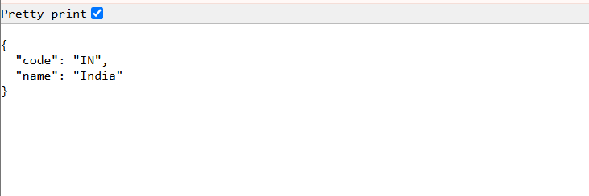

- REST - Get country exceptional scenario

Solution:

CountryNotFoundException.java
package com.cognizant.springlearn.exception;

import org.springframework.http.HttpStatus;
import org.springframework.web.bind.annotation.ResponseStatus;

@ResponseStatus(value = HttpStatus.NOT_FOUND, reason = "Country not found")
public class CountryNotFoundException extends Exception {

private static final long serialVersionUID = 1L;

public CountryNotFoundException(String message) {
super(message);
}
}

CountryService.java
package com.cognizant.springlearn.service;

import java.util.List;

import org.springframework.context.support.ClassPathXmlApplicationContext;
import org.springframework.stereotype.Service;

import com.cognizant.springlearn.exception.CountryNotFoundException;
import com.cognizant.springlearn.model.Country;

@Service
public class CountryService {

@SuppressWarnings("unchecked")
public Country getCountry(String code) throws CountryNotFoundException {

ClassPathXmlApplicationContext context =
new ClassPathXmlApplicationContext("country.xml");

List<Country> countryList =
(List<Country>) context.getBean("countryList");

return countryList.stream()
.filter(country -> country.getCode().equalsIgnoreCase(code))
.findFirst()
.orElseThrow(() ->
new CountryNotFoundException("Country not found"));
}
}

CountryController.java
package com.cognizant.springlearn.controller;

import org.slf4j.Logger;
import org.slf4j.LoggerFactory;
import org.springframework.beans.factory.annotation.Autowired;
import org.springframework.web.bind.annotation.GetMapping;
import org.springframework.web.bind.annotation.PathVariable;
import org.springframework.web.bind.annotation.RestController;

import com.cognizant.springlearn.exception.CountryNotFoundException;
import com.cognizant.springlearn.model.Country;
import com.cognizant.springlearn.service.CountryService;

@RestController
public class CountryController {

private static final Logger LOGGER =
LoggerFactory.getLogger(CountryController.class);

@Autowired
private CountryService countryService;

@GetMapping("/country/{code}")
public Country getCountry(@PathVariable String code)
throws CountryNotFoundException {

LOGGER.info("START");

Country country = countryService.getCountry(code);

LOGGER.info("END");

return country;
}
}

Output:
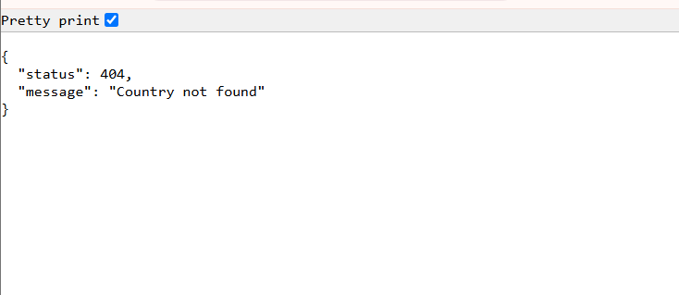

- MockMVC - Test get country service
Solution:
SpringLearnApplicationTests.java
package com.cognizant.springlearn;

import static org.junit.Assert.assertNotNull;
import static org.springframework.test.web.servlet.request.MockMvcRequestBuilders.get;
import static org.springframework.test.web.servlet.result.MockMvcResultMatchers.jsonPath;
import static org.springframework.test.web.servlet.result.MockMvcResultMatchers.status;
import org.junit.Test;
import org.junit.runner.RunWith;
import org.springframework.beans.factory.annotation.Autowired;
import org.springframework.boot.test.autoconfigure.web.servlet.AutoConfigureMockMvc;
import org.springframework.boot.test.context.SpringBootTest;
import org.springframework.test.context.junit4.SpringRunner;
import org.springframework.test.web.servlet.MockMvc;
import org.springframework.test.web.servlet.ResultActions;
import com.cognizant.springlearn.controller.CountryController;

@RunWith(SpringRunner.class)
@SpringBootTest
@AutoConfigureMockMvc
public class SpringLearnApplicationTests {

@Autowired
private CountryController countryController;

@Autowired
private MockMvc mvc;
@Test
public void contextLoads() {
assertNotNull(countryController);
}
@Test
public void testGetCountry() throws Exception {
ResultActions actions = mvc.perform(get("/country"));
actions.andExpect(status().isOk());
actions.andExpect(jsonPath("$.code").exists());
actions.andExpect(jsonPath("$.code").value("IN"));
actions.andExpect(jsonPath("$.name").exists());
actions.andExpect(jsonPath("$.name").value("India"));
}
}

Output:
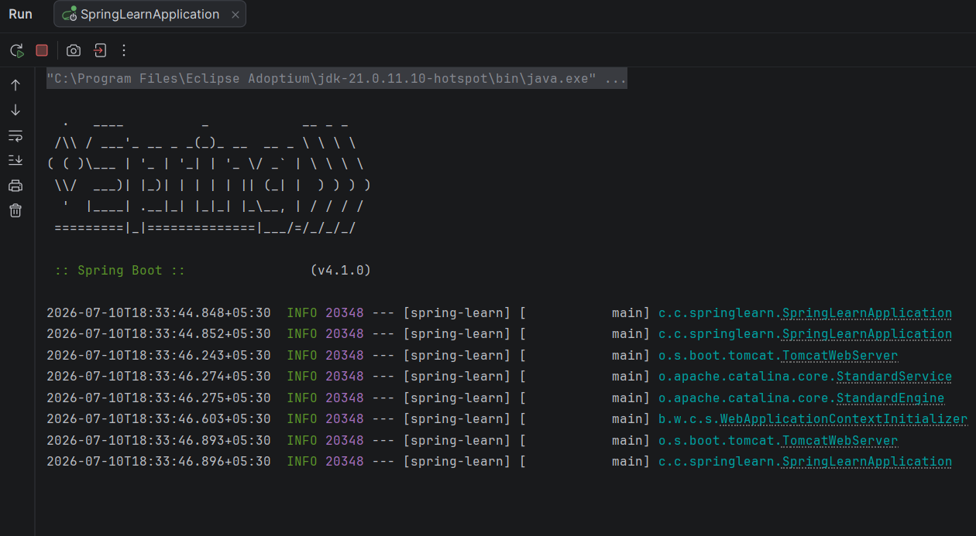
- MockMVC - Test get country service for exceptional scenario:

Solution:

SpringLearnApplicationTests.java
package com.cognizant.springlearn;

import static org.junit.Assert.assertNotNull;
import static org.springframework.test.web.servlet.request.MockMvcRequestBuilders.get;
import static org.springframework.test.web.servlet.result.MockMvcResultMatchers.jsonPath;
import static org.springframework.test.web.servlet.result.MockMvcResultMatchers.status;

import org.junit.Test;
import org.junit.runner.RunWith;
import org.springframework.beans.factory.annotation.Autowired;
import org.springframework.boot.test.autoconfigure.web.servlet.AutoConfigureMockMvc;
import org.springframework.boot.test.context.SpringBootTest;
import org.springframework.test.context.junit4.SpringRunner;
import org.springframework.test.web.servlet.MockMvc;
import org.springframework.test.web.servlet.ResultActions;

import com.cognizant.springlearn.controller.CountryController;

@RunWith(SpringRunner.class)
@SpringBootTest
@AutoConfigureMockMvc
public class SpringLearnApplicationTests {

@Autowired
private CountryController countryController;

@Autowired
private MockMvc mvc;

@Test
public void contextLoads() {
assertNotNull(countryController);
}

@Test
public void testGetCountry() throws Exception {

ResultActions actions = mvc.perform(get("/country"));

actions.andExpect(status().isOk());
actions.andExpect(jsonPath("$.code").exists());
actions.andExpect(jsonPath("$.code").value("IN"));
actions.andExpect(jsonPath("$.name").exists());
actions.andExpect(jsonPath("$.name").value("India"));
}

@Test
public void testGetCountryException() throws Exception {

ResultActions actions = mvc.perform(get("/country/zz"));

actions.andExpect(status().isBadRequest());
actions.andExpect(status().reason("Country Not found"));
}
}
CountryNotFoundException.java
(Required for the exception test to pass)
package com.cognizant.springlearn.exception;

import org.springframework.http.HttpStatus;
import org.springframework.web.bind.annotation.ResponseStatus;

@ResponseStatus(value = HttpStatus.BAD_REQUEST, reason = "Country Not found")
public class CountryNotFoundException extends RuntimeException {

private static final long serialVersionUID = 1L;

public CountryNotFoundException(String message) {
super(message);
}
}

Output:
